

*Annexure-6*

**Preparation of Integrated Transport Network Development Plan (ITNDP)**

**Sponsored by**

**MEGHALAYA INFRASTRUCTURE DEVELOPMENT FINANCE CORPORATION LTD**



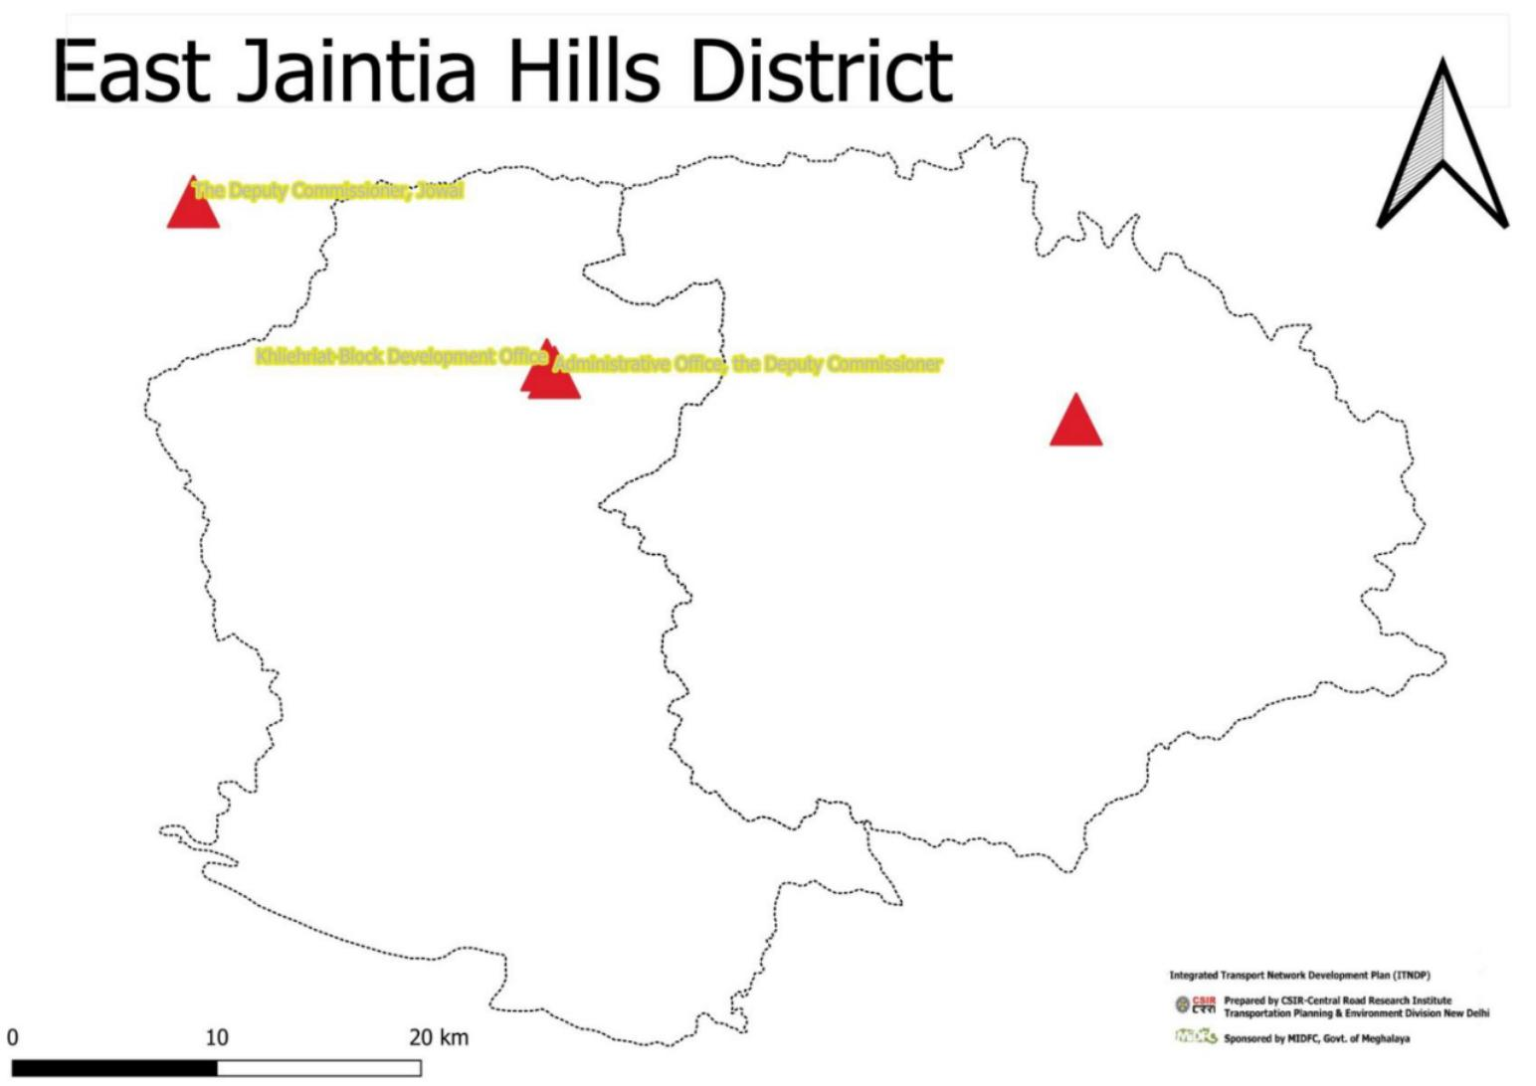

**District: East Jaintia Hills**

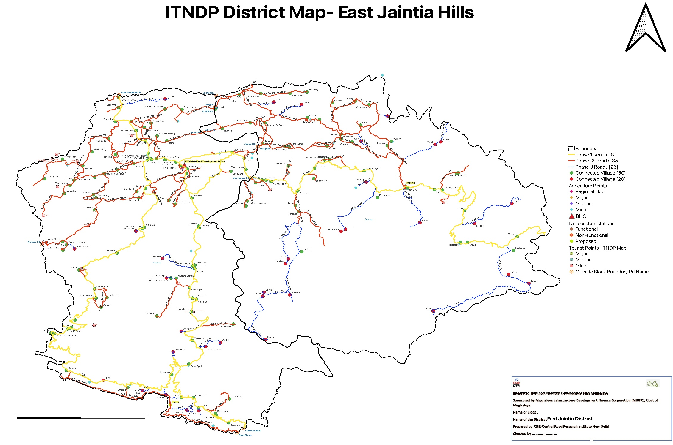

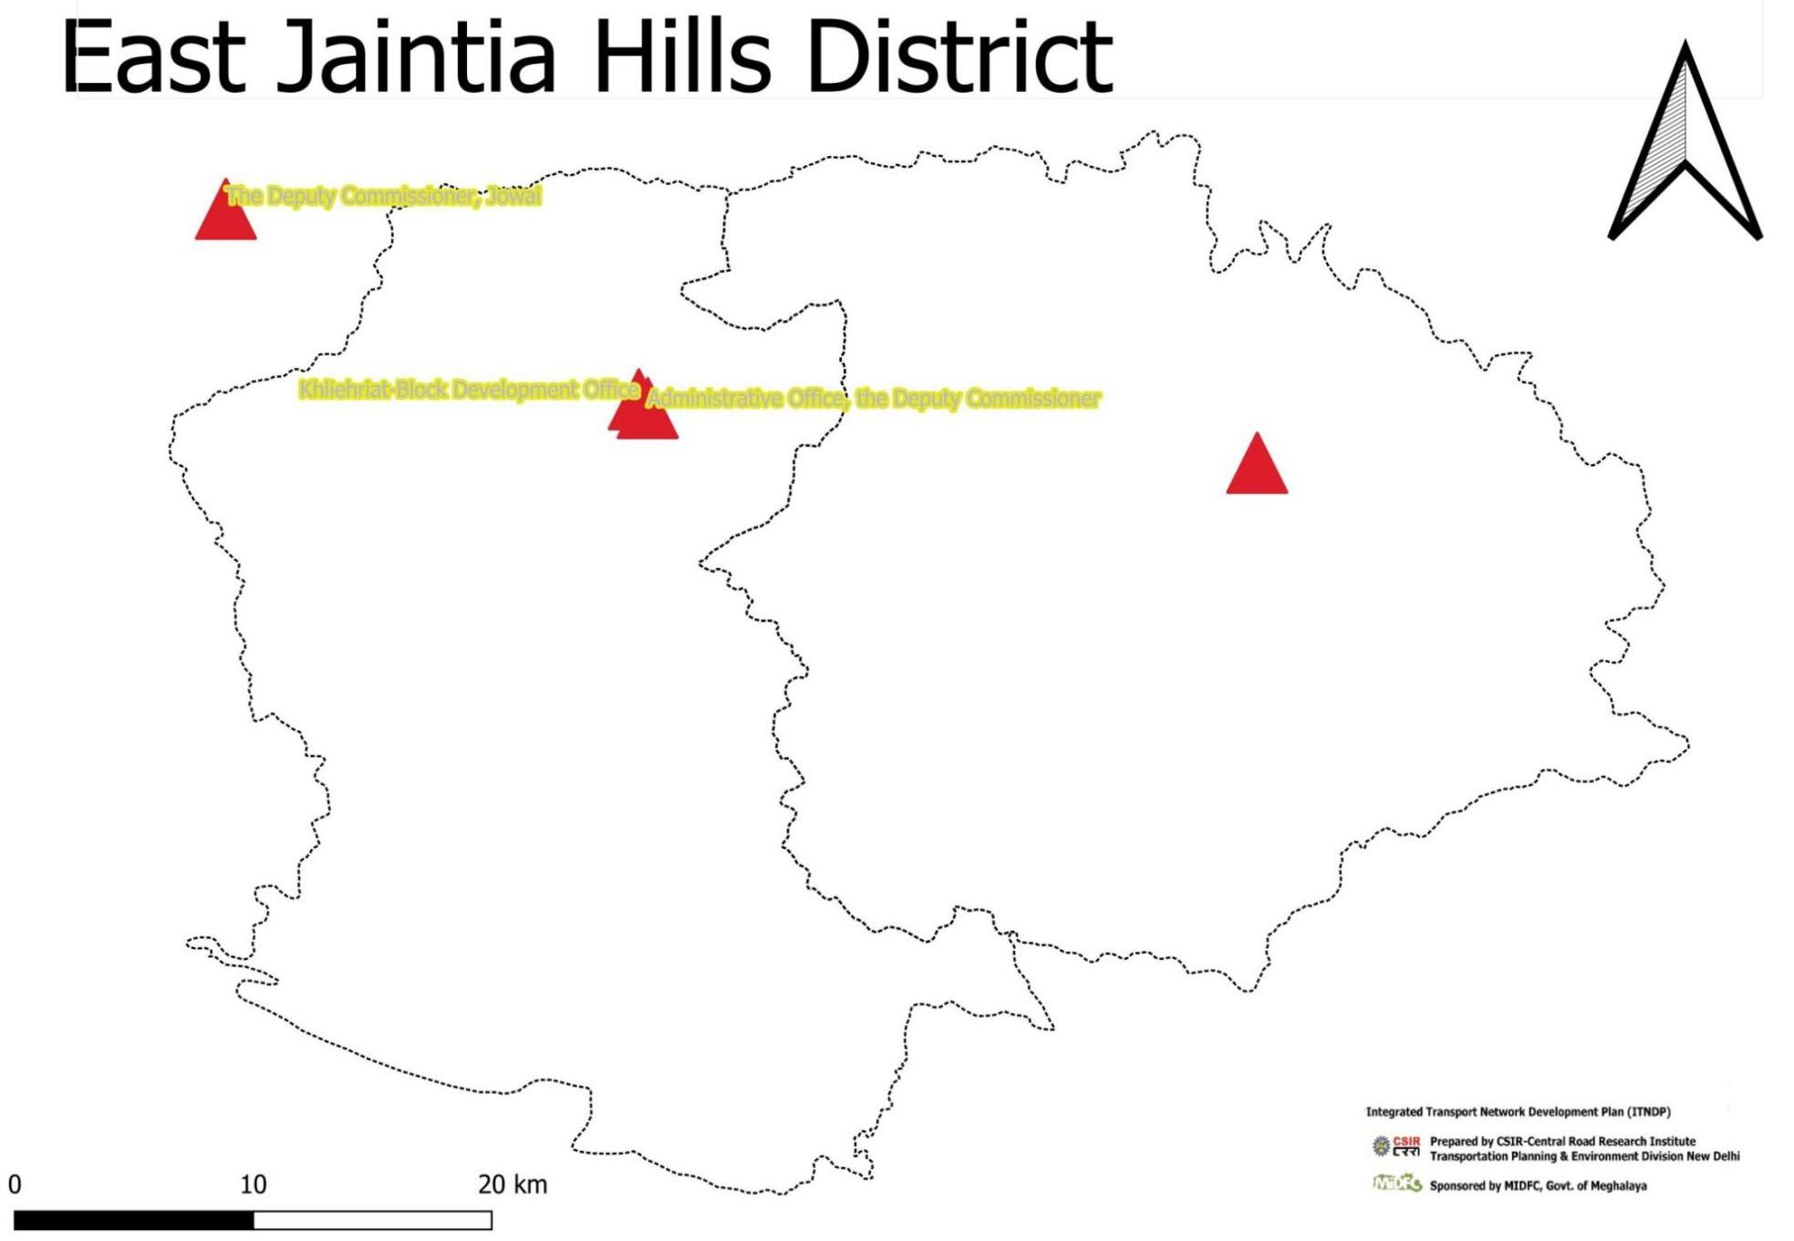

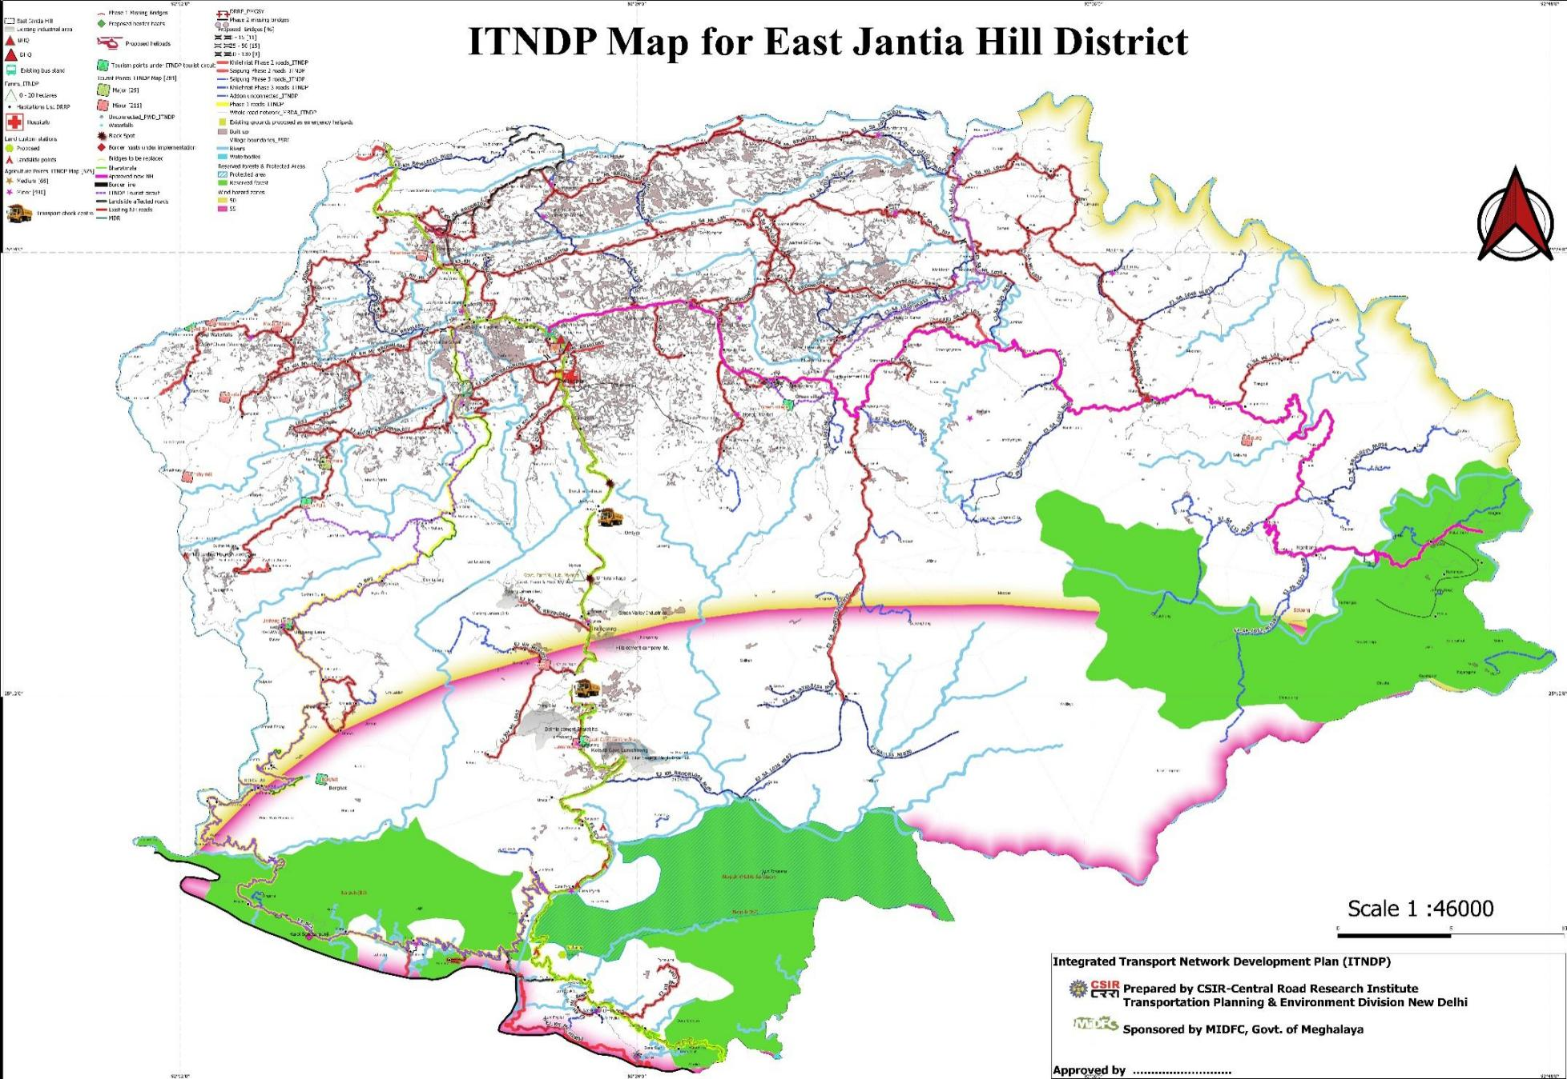

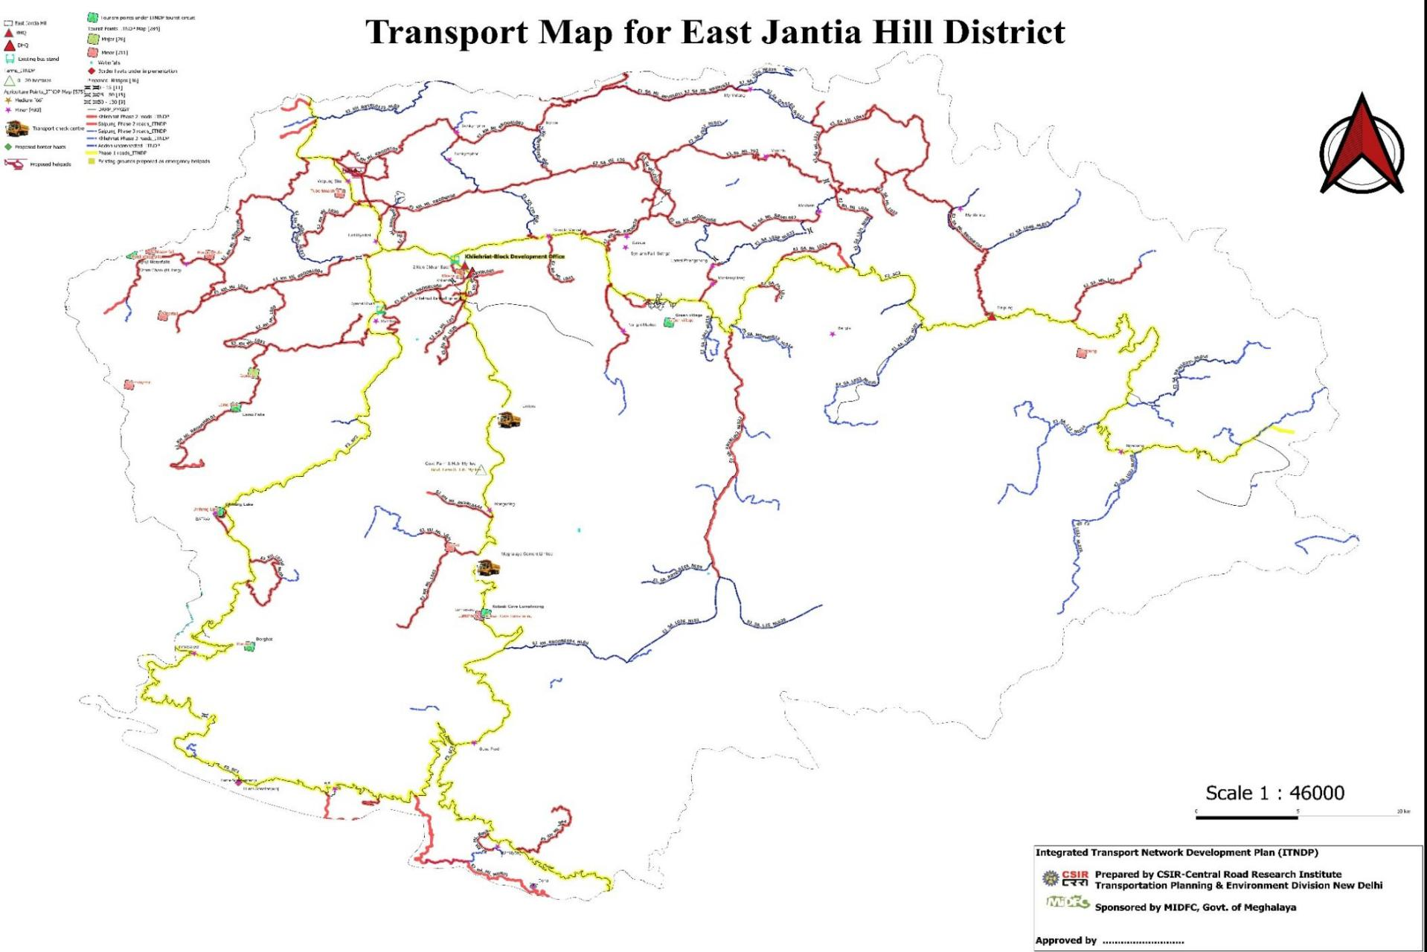

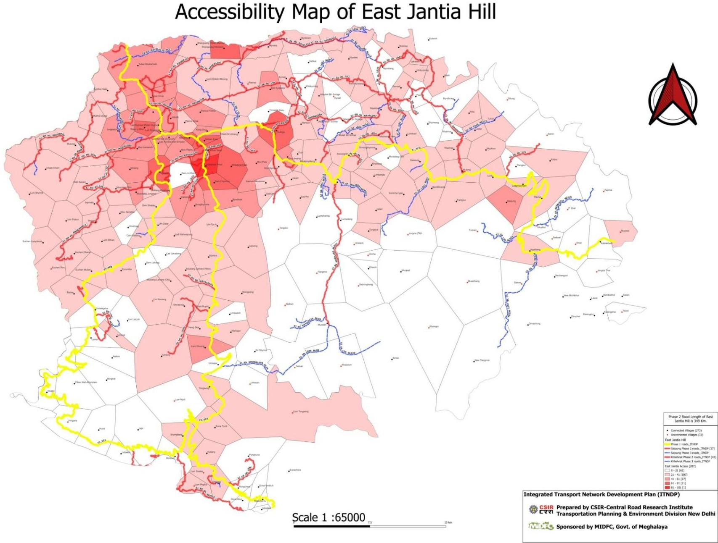

**FINANCIAL SUMMARY OF EAST JAINTIA HILL DISTRICT**

|  |  |  |  |
| --- | --- | --- | --- |
|  | Khliehriat | Saipung | EJH |
| Total No of Road | 14 | 13 | 27 |
| Total Length of New Construction(km) | 22.6 | 125.5 | 148.1 |
| Total Cost of Road | 2228.5 | 14831 | 17059.5 |
| Connected | 90 | 50 | 140 |
| Unconnected | 14 | 20 | 34 |
|  |  |  |  |
|  |  |  |  |
| Total no of Bridge Bridge/CD/Culvert upto 10m | 3 | 0 | 3 |
| Total no of Bridge Between 10 m-30 m | 1 | 3 | 4 |
| Total number of bridge Between 30-60m | 2 | 8 | 10 |
| Total no of bridge greater than 60m | 0 | 0 | 0 |
| Total no bridge | 6 | 11 | 17 |
| Total Cost of Bridge and Culvert | 280 | 3081.7 | 3361.7 |

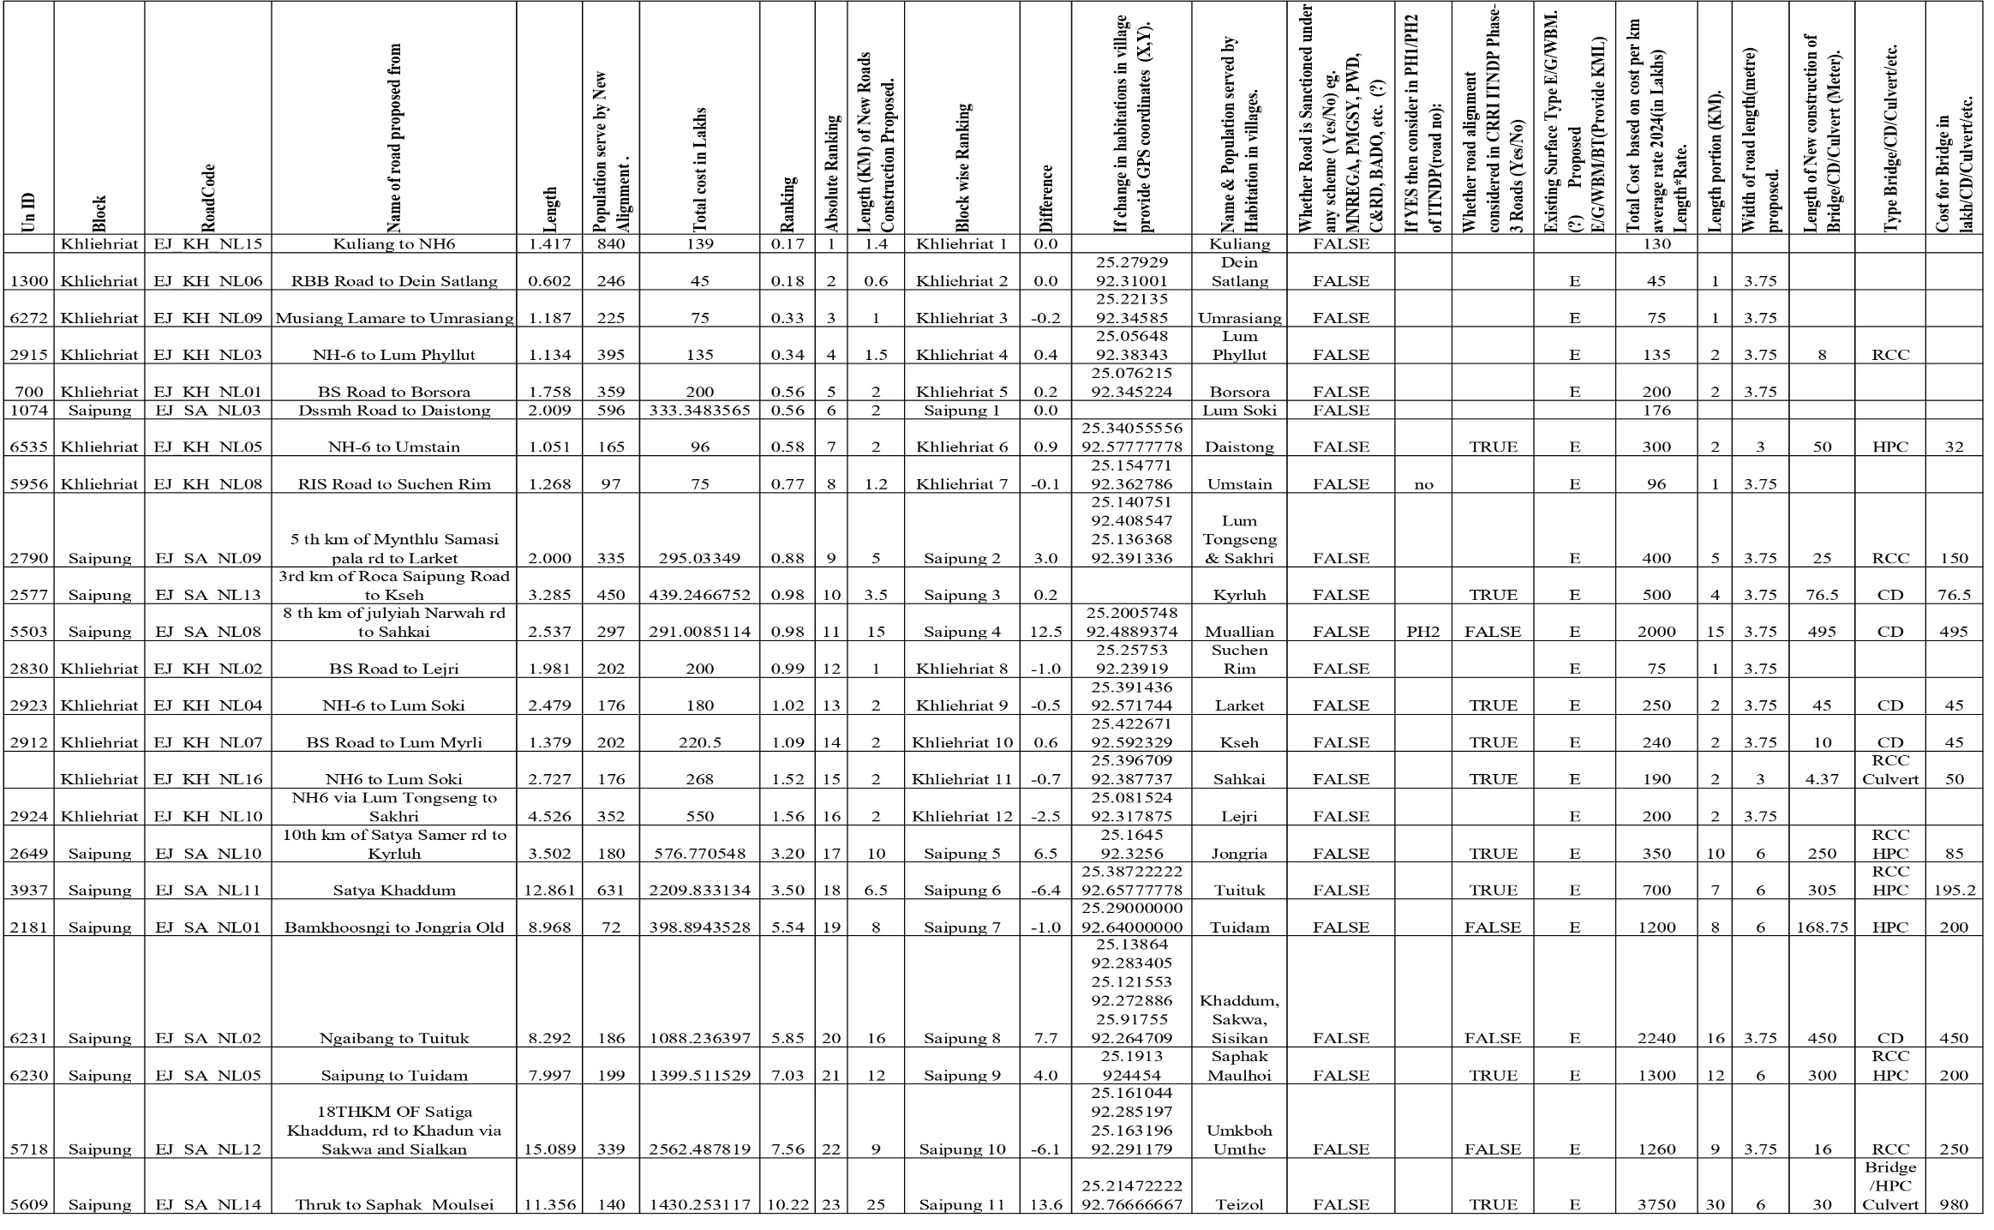**Summary of Yearly Financial allocation of Phase -3 roads and Bridge of ITNDP, District: EAST JAINTIA HILL**

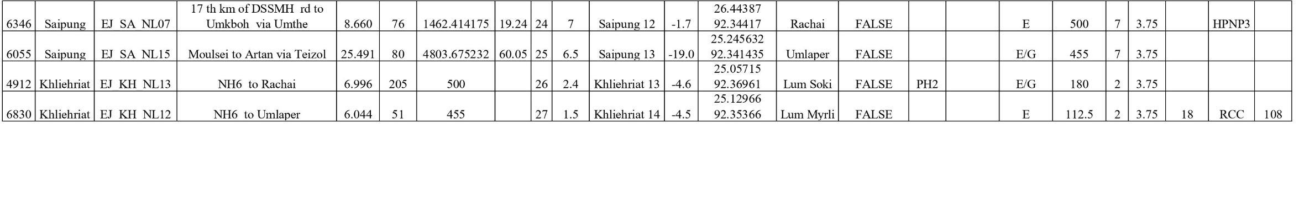

Financing Plan of Roads 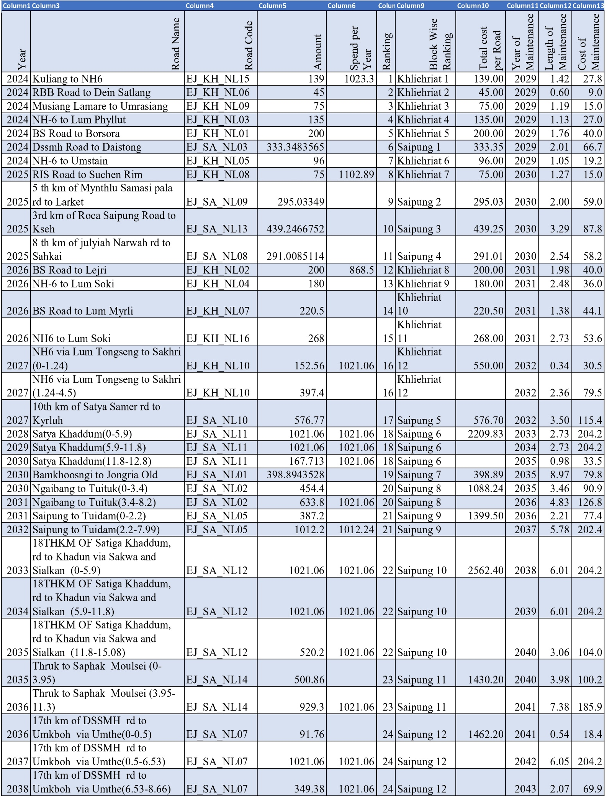

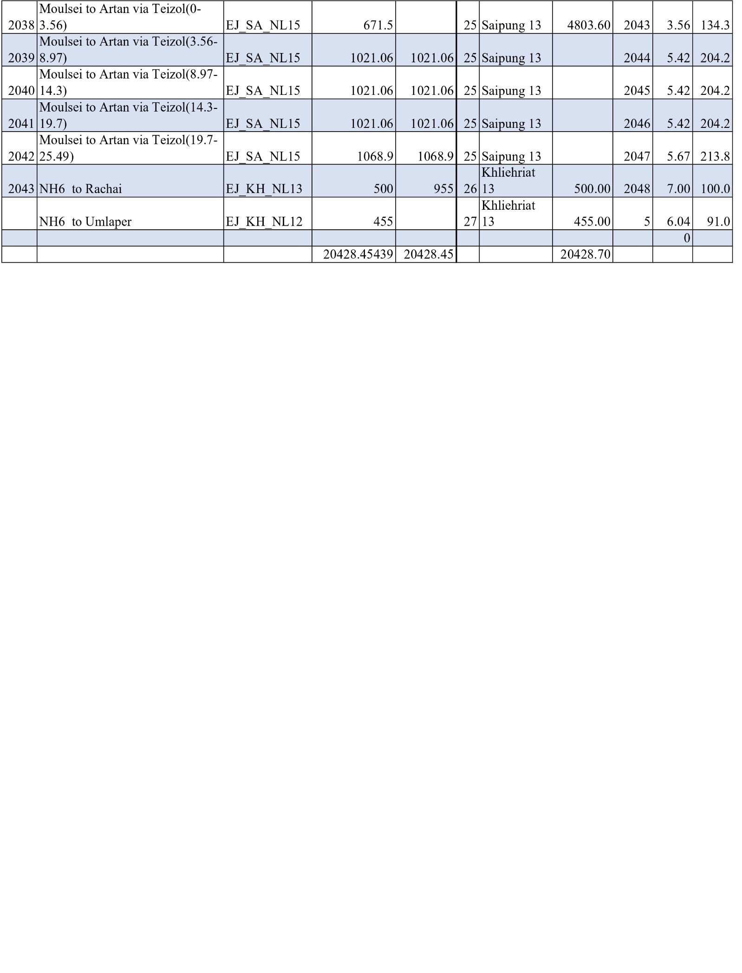



*Annexure-6-1*

**Preparation of Integrated Transport Network Development Plan (ITNDP)**

**Sponsored by**

**MEGHALAYA INFRASTRUCTURE DEVELOPMENT FINANCE CORPORATION LTD**



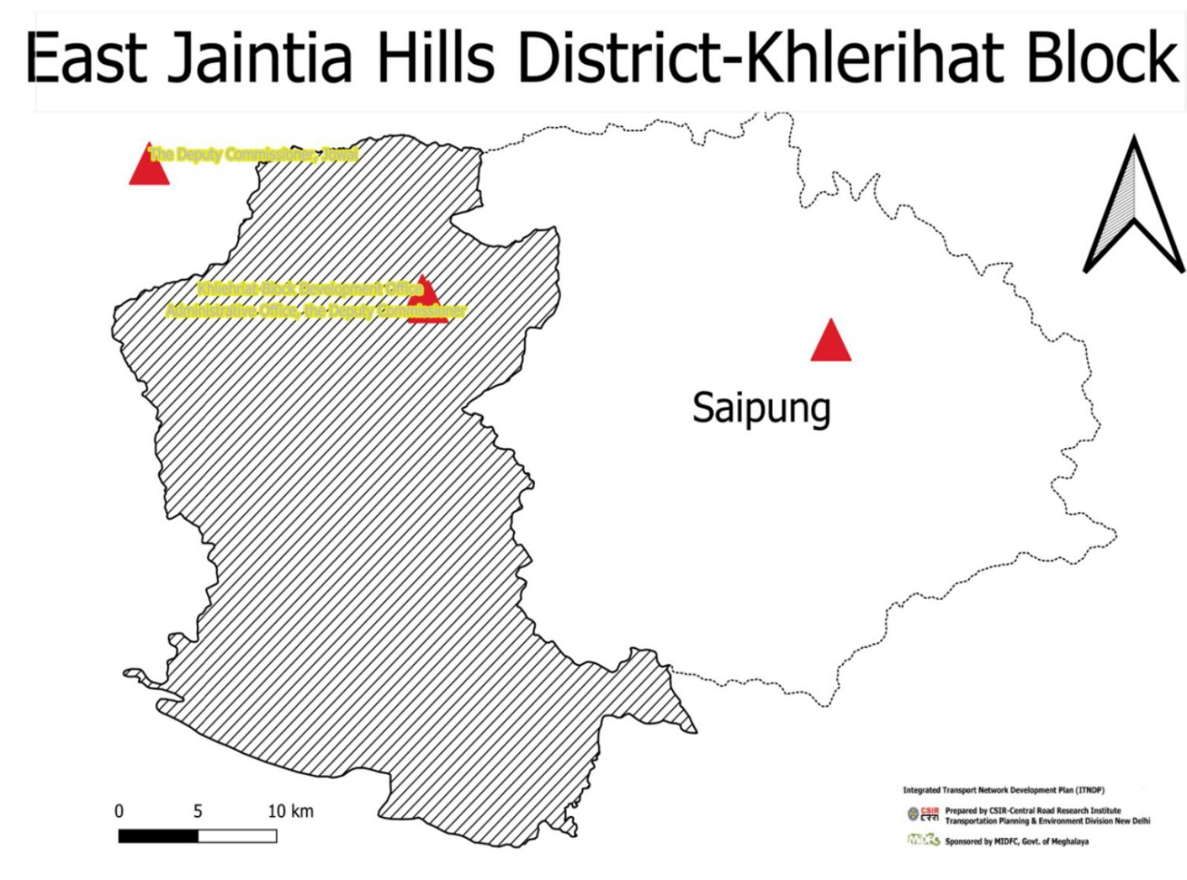

# District: East Jaintia Hills Block : Khliehriat C & RD Block

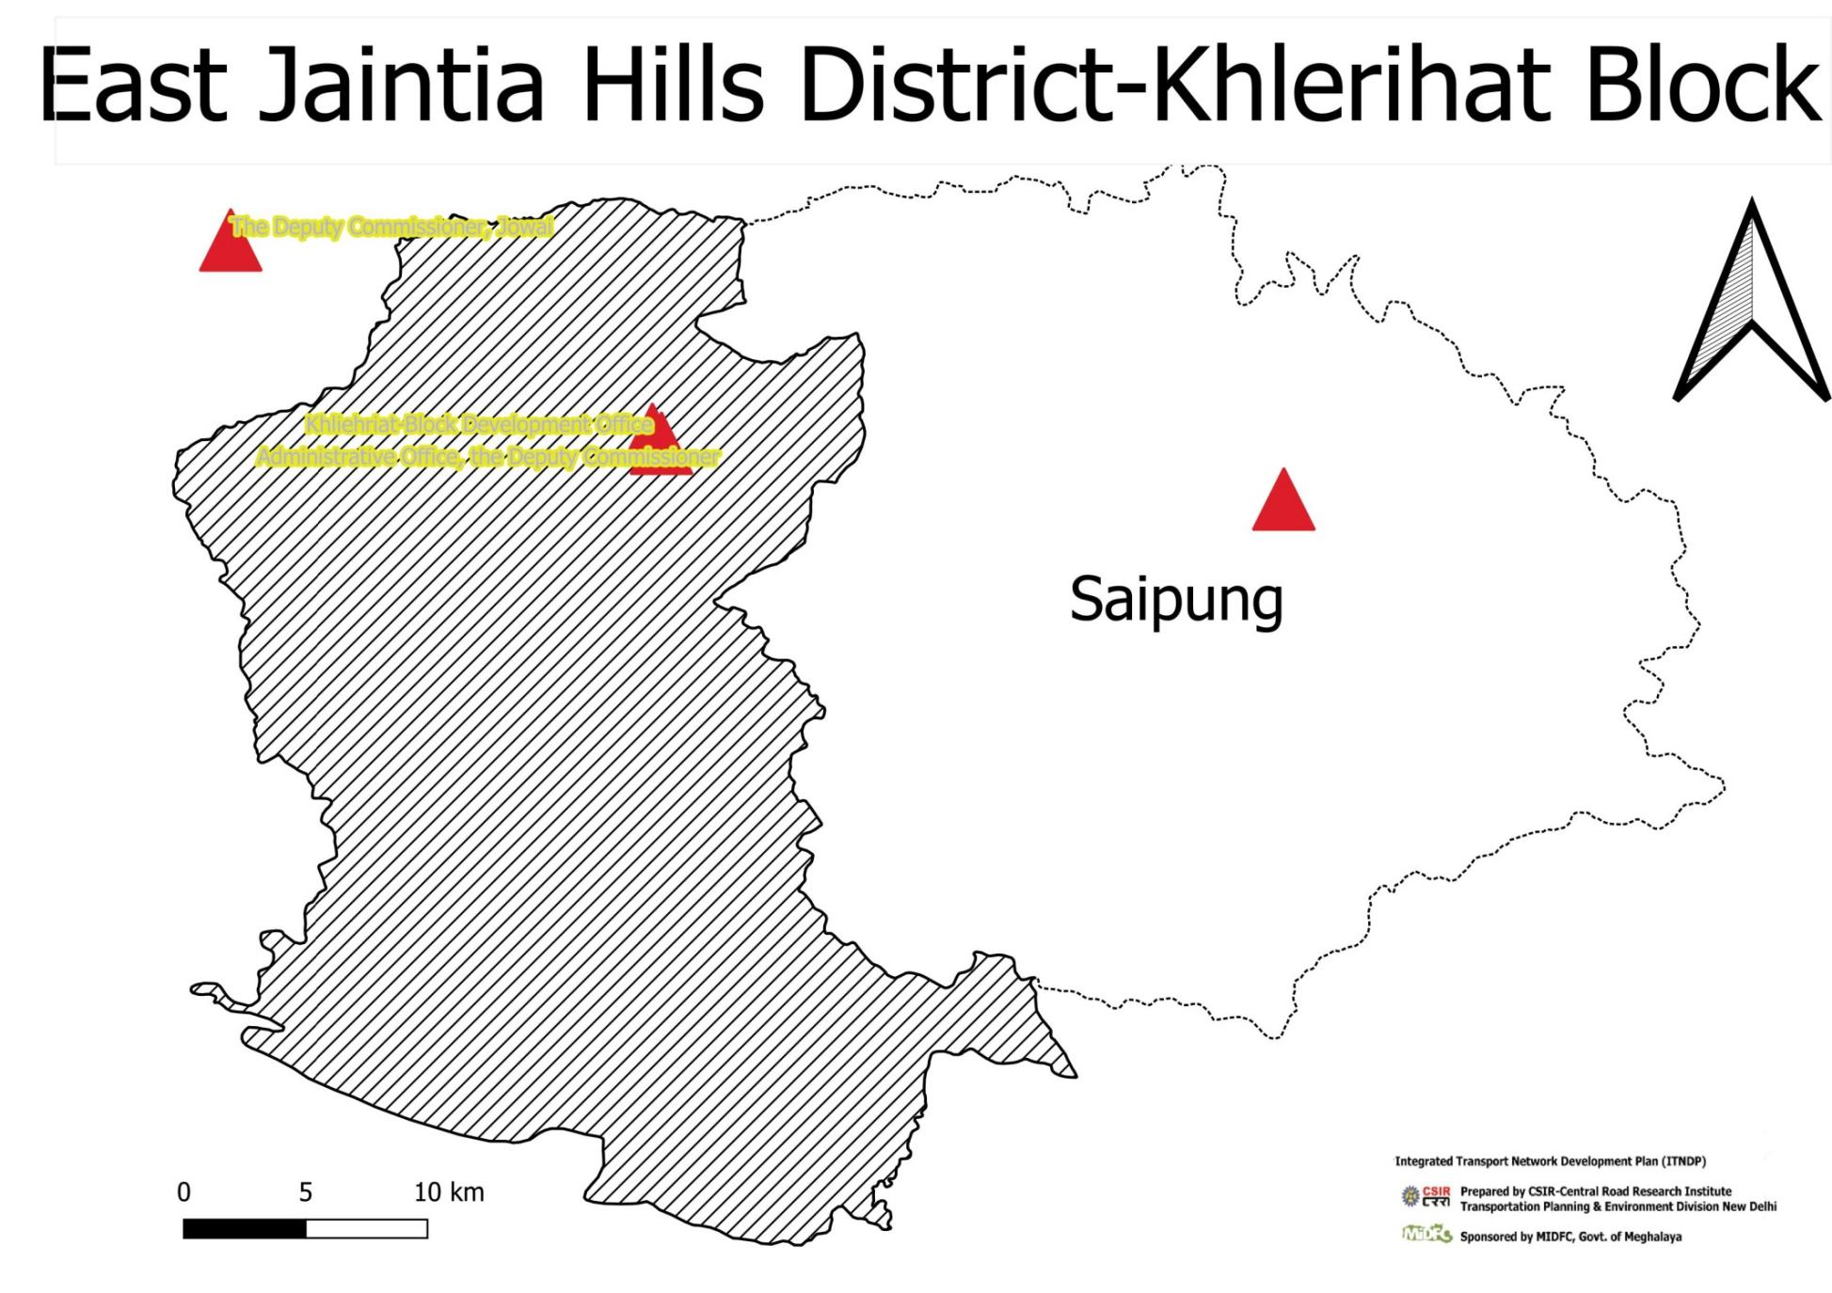

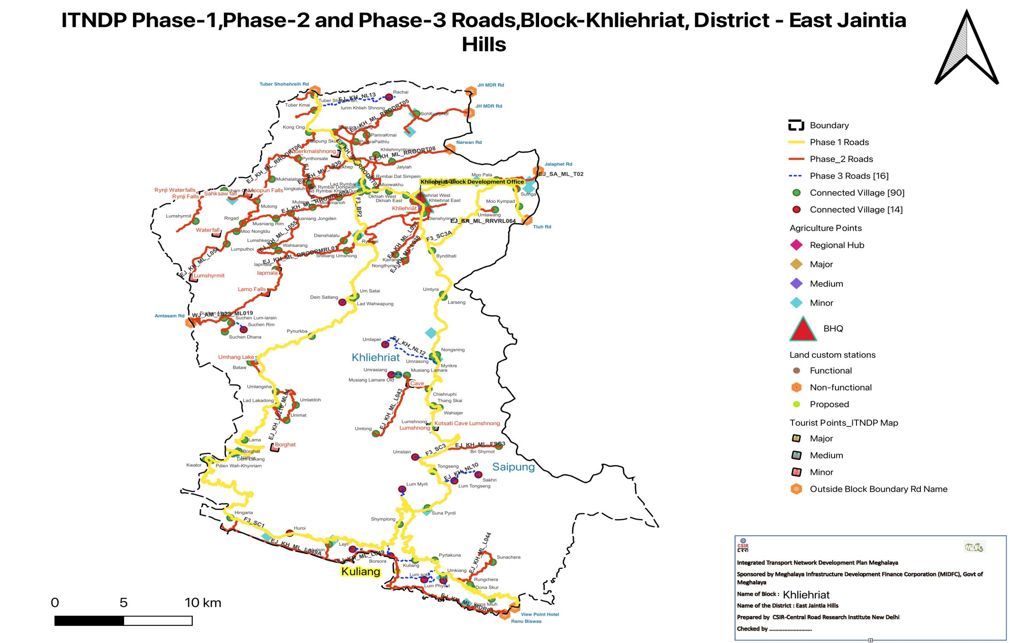

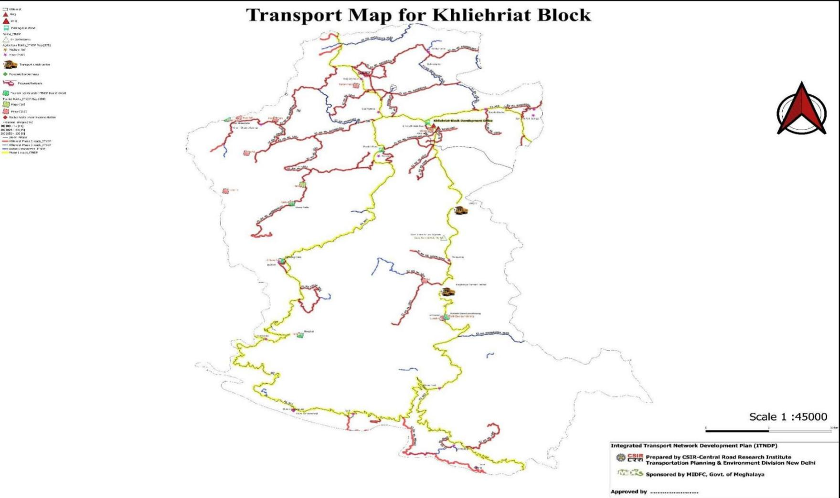

## Summary Sheet Phase-III ITNDP Khliehriat

## Financing Plan of Roads in Phase-III

**List of Connected Habitation East Jaintia Hill (Khlerihat Block)**

|  |  |  |  |  |  |
| --- | --- | --- | --- | --- | --- |
| **fid** | **Blok** | **Habitation** | **Population** | **X** | **Y** |
| 1 | Khliehriat | Khliehmyntriang | 363 | 92.33493368 | 25.39765189 |
| 2 | Khliehriat | Mookhep | 449 | 92.32118495 | 25.3920727 |
| 3 | Khliehriat | Bataw | 1509 | 92.24420289 | 25.23135888 |
| 4 | Khliehriat | Bri Shyrnot | 197 | 92.42347727 | 25.16407559 |
| 5 | Khliehriat | Lumputhoi | 564 | 92.22696437 | 25.32625618 |
| 6 | Khliehriat | Lumshyrmit | 1378 | 92.20444869 | 25.34445594 |
| 7 | Khliehriat | Moo Nongtdu | 305 | 92.2340144 | 25.33630458 |
| 8 | Khliehriat | Rngad | 1530 | 92.23861826 | 25.34281708 |
| 9 | Khliehriat | hiehruphi | 670 | 92.37274049 | 25.21000043 |
| 10 | Khliehriat | Byndihati | 2630 | 92.37529079 | 25.32071535 |
| 11 | Khliehriat | Khliehriat West | 3249 | 92.36168929 | 25.36112425 |
| 12 | Khliehriat | Dienshynrum | 705 | 92.36904804 | 25.35079045 |
| 13 | Khliehriat | Khliehriat East | 2191 | 92.36998128 | 25.35706092 |
| 14 | Khliehriat | Dona Mluh | 173 | 92.41819601 | 25.04171092 |
| 15 | Khliehriat | Hingaria | 930 | 92.22957857 | 25.1067656 |
| 16 | Khliehriat | Iapmala | 1104 | 92.26232699 | 25.30574223 |
| 17 | Khliehriat | Iongkaluh | 2182 | 92.28674275 | 25.37469639 |
| 18 | Khliehriat | Iurim Khlieh Shnong | 292 | 92.34413774 | 25.43109201 |
| 19 | Khliehriat | SohKymphor | 3277 | 92.36392438 | 25.43057756 |
| 20 | Khliehriat | Kairang | 394 | 92.34866363 | 25.31771939 |
| 21 | Khliehriat | Kwator | 206 | 92.2118612 | 25.15313953 |
| 22 | Khliehriat | Pdien Wah-Khynriam | 80 | 92.21587083 | 25.1526852 |
| 23 | Khliehriat | Lad Rymbai Dongwah | 545 | 92.32358608 | 25.36777456 |
| 24 | Khliehriat | Lad Rymbai B | 497 | 92.32671702 | 25.36996814 |
| 25 | Khliehriat | Lad Rymbai Khlieh Dupon | 520 | 92.32850169 | 25.36868036 |
| 26 | Khliehriat | Moowakhu | 435 | 92.33442844 | 25.36970558 |
| 27 | Khliehriat | Lad Rymbai Dat Simpein | 145 | 92.32484536 | 25.37629127 |
| 28 | Khliehriat | Lad Lakadong | 86 | 92.26402026 | 25.19668005 |
| 29 | Khliehriat | Ummat | 441 | 92.27006889 | 25.1849181 |
| 30 | Khliehriat | Lahalein | 406 | 92.30077111 | 25.08536555 |
| 31 | Khliehriat | Lumshnong | 1945 | 92.37474175 | 25.17976192 |
| 32 | Khliehriat | Kuliang | 843 | 92.3630521 | 25.07276018 |
| 33 | Khliehriat | Pyrtakuna | 516 | 92.37716079 | 25.07276018 |
| 34 | Khliehriat | Molamanoh | 1431 | 92.30796276 | 25.36350315 |
| 35 | Khliehriat | Mulang | 951 | 92.2888915 | 25.35567421 |
| 36 | Khliehriat | Umlawang | 309 | 92.42067293 | 25.35370499 |
| 37 | Khliehriat | Dkhiah East | 2019 | 92.35663467 | 25.36522291 |
| 38 | Khliehriat | Mukhaialong | 1597 | 92.25951422 | 25.37813233 |
| 39 | Khliehriat | Dienshalalu | 229 | 92.31142098 | 25.32882696 |
| 40 | Khliehriat | ham ham | 1453 | 92.22513629 | 25.3689238 |
| 41 | Khliehriat | Musniang Jongden | 1567 | 92.27329722 | 25.35087771 |
| 42 | Khliehriat | Musniang Rim | 591 | 92.26251764 | 25.34669448 |
| 43 | Khliehriat | Mutong | 815 | 92.24856196 | 25.36067676 |
| 44 | Khliehriat | Mynkre | 335 | 92.37856363 | 25.23276684 |
| 45 | Khliehriat | Nongsning | 563 | 92.37880394 | 25.23739492 |
| 46 | Khliehriat | Umrasong | 196 | 92.37584617 | 25.23626825 |
| 47 | Khliehriat | Nongthymme | 473 | 92.35593319 | 25.31294644 |
| 48 | Khliehriat | Dkhiah West | 649 | 92.34428031 | 25.3684811 |
| 49 | Khliehriat | Jalyiah | 1359 | 92.3463794 | 25.39206085 |
| 50 | Khliehriat | Borghat | 281 | 92.2355821 | 25.1599341 |
| 51 | Khliehriat | Dem Lakang | 45 | 92.23137857 | 25.15806656 |
| 52 | Khliehriat | Lama | 338 | 92.23985288 | 25.16918676 |
| 53 | Khliehriat | Natbor | 192 | 92.2341132 | 25.15899606 |
| 54 | Khliehriat | Pynthorsale | 504 | 92.27837644 | 25.39462346 |
| 55 | Khliehriat | Pynurkba | 414 | 92.28833765 | 25.25226501 |
| 56 | Khliehriat | Dona Skur | 427 | 92.40359775 | 25.05090118 |
| 57 | Khliehriat | Runghera | 0 | 92.40259313 | 25.05326814 |
| 58 | Khliehriat | Rymbai | 4788 | 92.32147459 | 25.33246315 |
| 59 | Khliehriat | Shilliang Umshong | 407 | 92.31357235 | 25.32091877 |
| 60 | Khliehriat | Shymplong | 293 | 92.35184627 | 25.10156483 |
| 61 | Khliehriat | Suhen Dhana | 239 | 92.22561379 | 25.25578041 |
| 62 | Khliehriat | Suhen Lum-iarain | 143 | 92.23024615 | 25.26295492 |
| 63 | Khliehriat | Suhen Mulieh | 333 | 92.22500329 | 25.2667892 |
| 64 | Khliehriat | Suna Pyrdi | 651 | 92.3720352 | 25.11469256 |
| 65 | Khliehriat | Sunahera | 0 | 92.41903681 | 25.07110046 |
| 66 | Khliehriat | Moo Kympad | 829 | 92.43810813 | 25.35628899 |
| 67 | Khliehriat | Moo Pala | 443 | 92.42181011 | 25.37756528 |
| 68 | Khliehriat | Sutnga | 3608 | 92.43625887 | 25.37028906 |
| 69 | Khliehriat | Thang Skai | 635 | 92.37611078 | 25.19650371 |
| 70 | Khliehriat | Tongseng | 486 | 92.37606158 | 25.1439211 |
| 71 | Khliehriat | Bapung Skur | 2289 | 92.31050069 | 25.40451416 |
| 72 | Khliehriat | PamraPaithlu | 1070 | 92.32010201 | 25.40812487 |
| 73 | Khliehriat | Bapung shnong | 2249 | 92.30464615 | 25.41582558 |
| 74 | Khliehriat | Kong Ong | 75 | 92.28643852 | 25.41578378 |
| 75 | Khliehriat | PamraKmai | 1320 | 92.32805763 | 25.41345908 |
| 76 | Khliehriat | Tuber Kmai | 2139 | 92.29014883 | 25.43338764 |
| 77 | Khliehriat | Tuber Shohshrieh | 1228 | 92.29018686 | 25.44542431 |
| 78 | Khliehriat | Lad Wahwapung | 228 | 92.31793686 | 25.2825567 |
| 79 | Khliehriat | Um Satai | 239 | 92.3200137 | 25.28440649 |
| 80 | Khliehriat | Umkiang | 3082 | 92.38326968 | 25.06039504 |
| 81 | Khliehriat | Umlangsha | 132 | 92.26249718 | 25.20777793 |
| 82 | Khliehriat | Umlong | 418 | 92.33467049 | 25.1741523 |
| 83 | Khliehriat | Umlatdoh | 349 | 92.27683799 | 25.19709992 |
| 84 | Khliehriat | Musiang Lamare | 264 | 92.35707442 | 25.22095661 |
| 85 | Khliehriat | Musiang Lamare Old | 638 | 92.35081358 | 25.22134431 |
| 86 | Khliehriat | Larseng | 96 | 92.38360621 | 25.28363482 |
| 87 | Khliehriat | Umtyra | 435 | 92.38305389 | 25.2857999 |
| 88 | Khliehriat | Lumshken | 707 | 92.26109484 | 25.32487568 |
| 89 | Khliehriat | Wahsarang | 713 | 92.26442177 | 25.32101086 |
| 90 | Khliehriat | Wahiajer | 602 | 92.38065046 | 25.19495093 |

**List of Unconnected Habitation East Jaintia Hill (Khlerihat Block)**

|  |  |  |  |  |  |
| --- | --- | --- | --- | --- | --- |
| **fid** | **Block** | **Habitation** | **Population** | **X** | **Y** |
| 1 | Khliehriat | Borsora | 359 | 92.345224 | 25.076215 |
| 2 | Khliehriat | Lejri | 202 | 92.317875 | 25.081524 |
| 3 | Khliehriat | Lm Phyllt | 395 | 92.38343 | 25.05648 |
| 4 | Khliehriat | Lm soki | 1776 | 92.36961 | 25.05715 |
| 5 | Khliehriat | mstain | 165 | 92.36302664 | 25.15540736 |
| 6 | Khliehriat | Dein Satlang | 246 | 92.31049171 | 25.27947588 |
| 7 | Khliehriat | Lm Myrli | 202 | 92.35366 | 25.12966 |
| 8 | Khliehriat | Schen Rim | 97 | 92.23919 | 25.25753 |
| 9 | Khliehriat | mrasiang | 225 | 92.34585 | 25.22135 |
| 10 | Khliehriat | Sakhri | 352 | 92.40870357 | 25.14125549 |
| 11 | Khliehriat | Lm Tongseng | 102 | 92.391336 | 25.136368 |
| 12 | Khliehriat | mlaper | 51 | 92.341435 | 25.245632 |
| 13 | Khliehriat | Rachai | 205 | 92.34417 | 25.44387 |
| 14 | Khliehriat | Hroi | 917 | 92.272499 | 25.094372 |





*Annexure-6-2*

**Preparation of Integrated Transport Network Development Plan (ITNDP)**

**Sponsored by**

**MEGHALAYA INFRASTRUCTURE DEVELOPMENT FINANCE CORPORATION LTD**

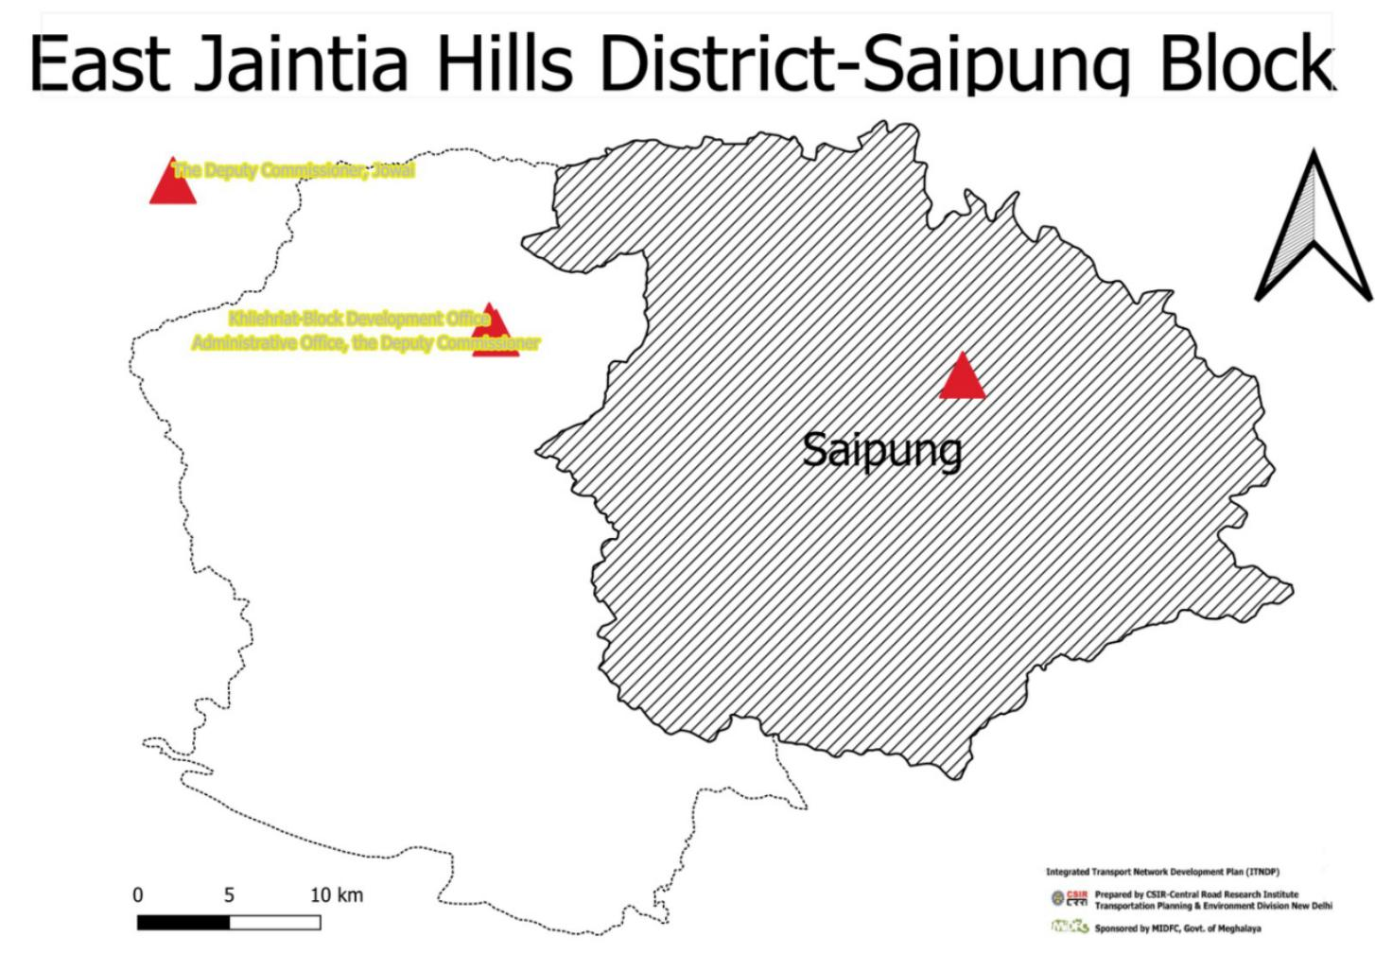

# District: East Jaintia Hills Block: Saipung C & RD Block

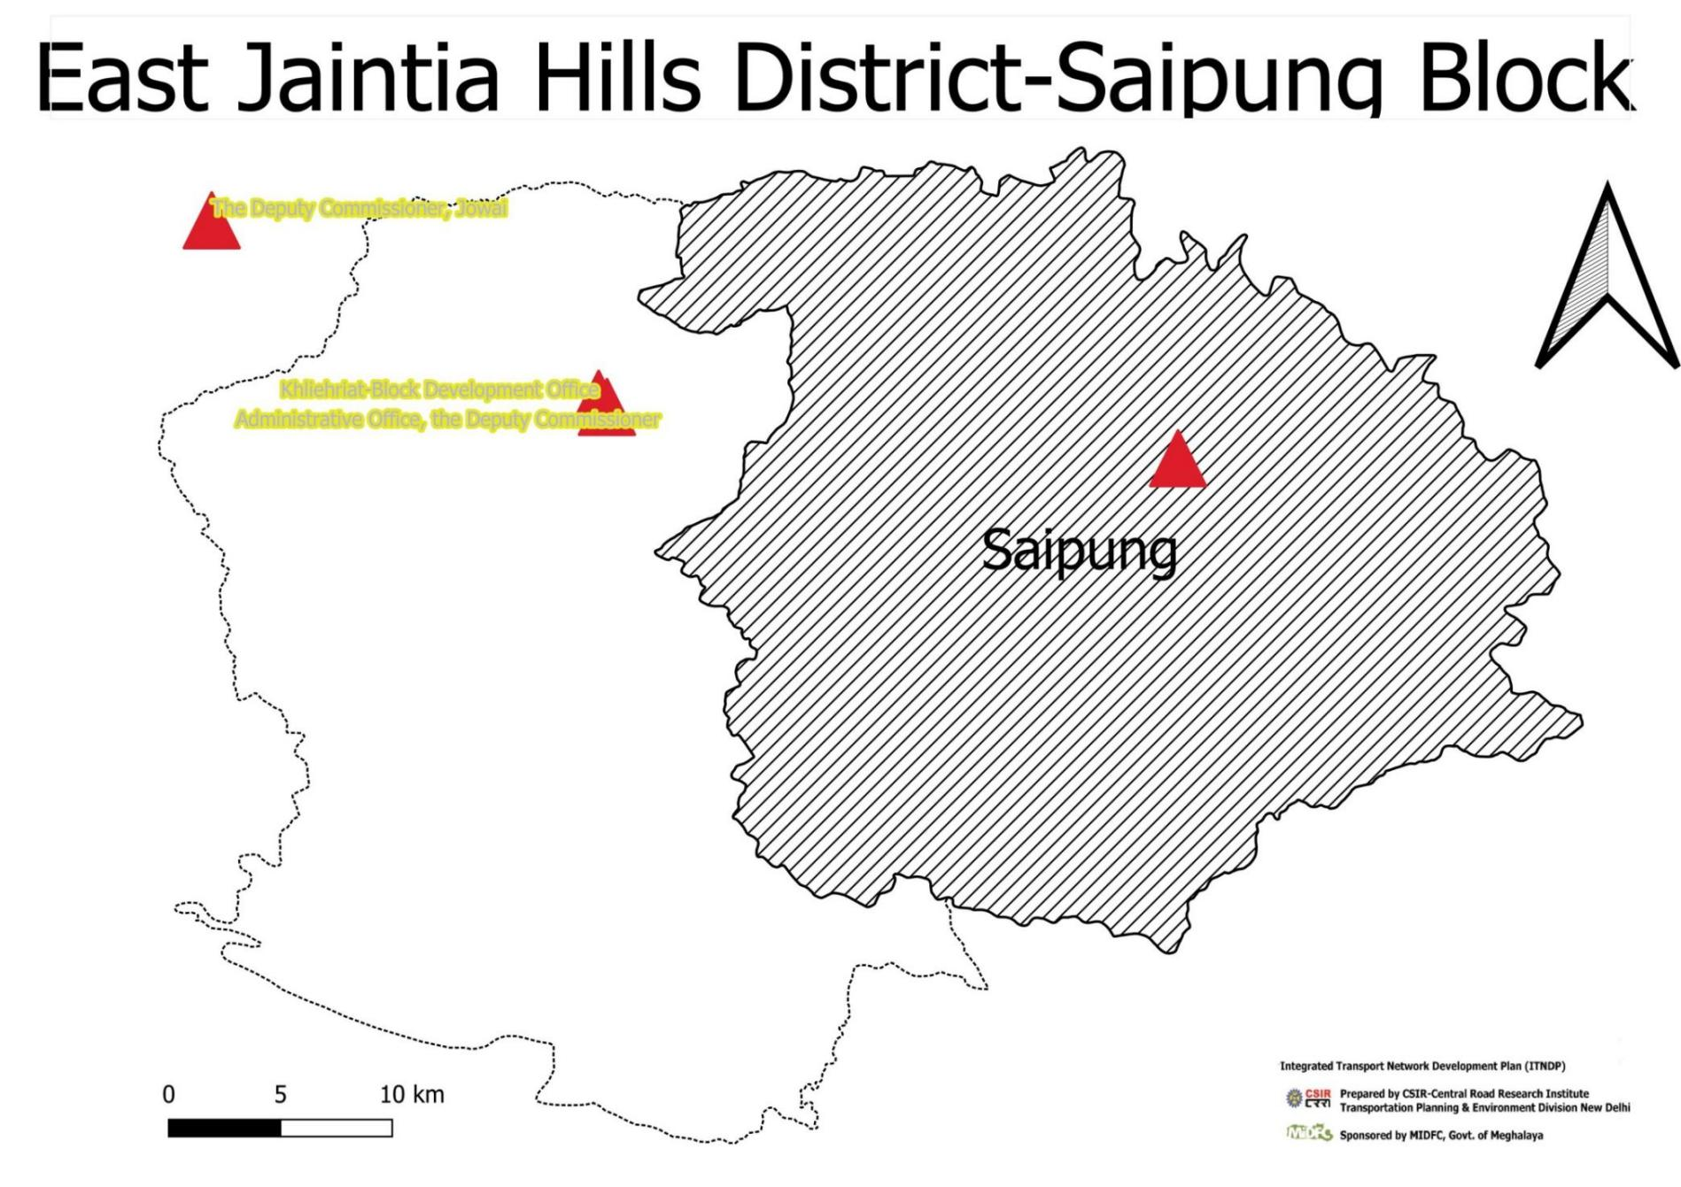

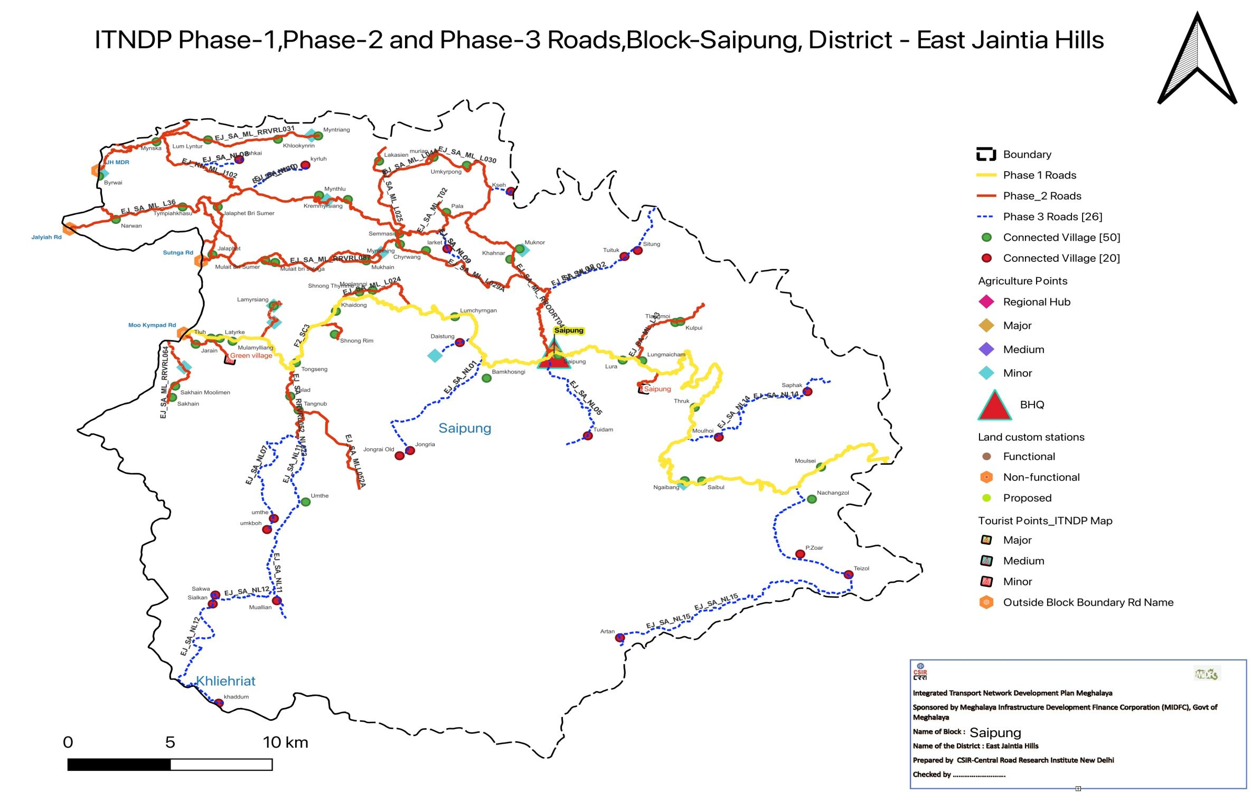

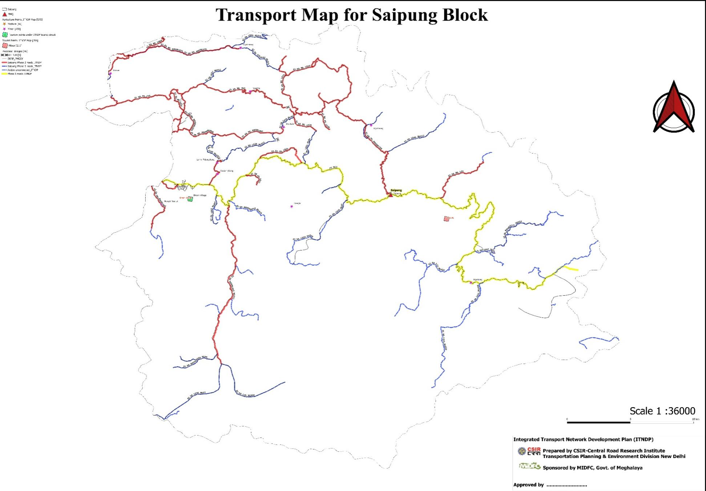

# Summary Sheet Phase-IIII TNDP of Saipung

# Financing Plan of Roads in Phase-III

**List of Connected Habitation East Jaintia Hill (Saipung Block)**

|  |  |  |  |  |  |
| --- | --- | --- | --- | --- | --- |
| **fid** | **fid** | **fid** | **fid** | **X** | **Y** |
| 1 | Saipung | Bamkhosngi | 236 | 92.59083165 | 25.32122726 |
| 2 | Saipung | Tympiahkhasu | 145 | 92.44314478 | 25.41408026 |
| 3 | Saipung | Lumhyrngan | 194 | 92.57539167 | 25.35457072 |
| 4 | Saipung | Mulait Bri Sumer | 663 | 92.48331074 | 25.38513858 |
| 5 | Saipung | Mulait bri sutnga | 316 | 92.48806432 | 25.38397045 |
| 6 | Saipung | Nahangzol | 109 | 92.74882279 | 25.25564693 |
| 7 | Saipung | Jalaphet Bri Sumer | 2292 | 92.46020832 | 25.41413231 |
| 8 | Saipung | Kremmyrsiang | 458 | 92.52341198 | 25.41811668 |
| 9 | Saipung | Kulpui | 261 | 92.68494832 | 25.35199253 |
| 10 | Saipung | Tlangmoi | 168 | 92.68247646 | 25.35144267 |
| 11 | Saipung | Umkyrpong | 613 | 92.58119657 | 25.4366629 |
| 12 | Saipung | Tangnub | 410 | 92.49949027 | 25.30392315 |
| 13 | Saipung | Lelad | 552 | 92.49543462 | 25.3114635 |
| 14 | Saipung | Lura | 431 | 92.65692516 | 25.33106239 |
| 15 | Saipung | Jarain | 603 | 92.44953728 | 25.33965386 |
| 16 | Saipung | hyrwang | 139 | 92.56136461 | 25.39046378 |
| 17 | Saipung | Mukhain | 436 | 92.53235184 | 25.3848758 |
| 18 | Saipung | Mynthning | 440 | 92.54870106 | 25.39383056 |
| 19 | Saipung | Semmasi | 513 | 92.54839994 | 25.39957969 |
| 20 | Saipung | Lamyrsiang | 846 | 92.48741385 | 25.36051454 |
| 21 | Saipung | Mulamylliang | 733 | 92.46739996 | 25.34125802 |
| 22 | Saipung | Moolasngi | 385 | 92.53542352 | 25.36886596 |
| 23 | Saipung | Shnong Thymme | 148 | 92.52897461 | 25.36793983 |
| 24 | Saipung | muriap | 157 | 92.56503438 | 25.44098994 |
| 25 | Saipung | Saipung | 1431 | 92.62571518 | 25.33375011 |
| 26 | Saipung | Lum Lyntur | 194 | 92.45546142 | 25.45044195 |
| 27 | Saipung | Mynska | 2328 | 92.43041753 | 25.44943092 |
| 28 | Saipung | Mynthlu | 843 | 92.50945546 | 25.42041794 |
| 29 | Saipung | Myntriang | 531 | 92.50900379 | 25.45259002 |
| 30 | Saipung | Khahnar | 658 | 92.60229982 | 25.38568081 |
| 31 | Saipung | Muknor | 478 | 92.60683154 | 25.39138747 |
| 32 | Saipung | Lakasien | 491 | 92.5385826 | 25.43892758 |
| 33 | Saipung | Jalaphet | 2945 | 92.45764138 | 25.38819631 |
| 34 | Saipung | Ngaibang | 90 | 92.68705369 | 25.26565783 |
| 35 | Saipung | Pala | 755 | 92.571157 | 25.41114394 |
| 36 | Saipung | Byrwai | 1857 | 92.40251342 | 25.43074027 |
| 37 | Saipung | Narwan | 3372 | 92.410733 | 25.40733109 |
| 38 | Saipung | Khlookynrin | 904 | 92.48944685 | 25.45079034 |
| 39 | Saipung | Khaidong | 179 | 92.51759691 | 25.3575563 |
| 40 | Saipung | Shnong Rim | 966 | 92.51706518 | 25.34501677 |
| 41 | Saipung | Sakhain | 797 | 92.43805262 | 25.31081416 |
| 42 | Saipung | Sakhain Moolimen | 792 | 92.43956578 | 25.31696111 |
| 43 | Saipung | Thruk | 719 | 92.69190356 | 25.30545967 |
| 44 | Saipung | Lungmaiham | 102 | 92.66641691 | 25.33067799 |
| 45 | Saipung | Latyrke | 1120 | 92.46121792 | 25.34283255 |
| 46 | Saipung | Tongseng | 852 | 92.49819344 | 25.32961874 |
| 47 | Saipung | Tluh | 953 | 92.45697189 | 25.34295332 |
| 48 | Saipung | Umthe | 76 | 92.50292879 | 25.25411457 |
| 49 | Saipung | Moulsei | 905 | 92.75323788 | 25.27302764 |
| 50 | Saipung | Saibul | 422 | 92.69555556 | 25.26555556 |

**List of Unconnected Habitation East Jaintia Hill (Saipung Block)**

|  |  |  |  |  |  |
| --- | --- | --- | --- | --- | --- |
| **fid** | **Block** | **Habitation** | **Population** | **X** | **Y** |
| 1 | Saipung | Teizol | 80 | 92.76666667 | 25.21472222 |
| 2 | Saipung | Artan | 106 | 92.65560908 | 25.18047643 |
| 3 | Saipung | Titk | 186 | 92.65777778 | 25.38722222 |
| 4 | Saipung | Daistng | 596 | 92.57777778 | 25.34055556 |
| 5 | Saipung | Tidam | 199 | 92.64 | 25.29 |
| 6 | Saipung | Molhoi | 277 | 92.70357012 | 25.28923491 |
| 7 | Saipung | Jongria | 72 | 92.55363202 | 25.28199348 |
| 8 | Saipung | Saphak | 140 | 92.74669135 | 25.31396704 |
| 9 | Saipung | Sitng | 83 | 92.66422591 | 25.39049983 |
| 10 | Saipung | Kseh | 450 | 92.60268038 | 25.42253084 |
| 11 | Saipung | khaddm | 91 | 92.46070108 | 25.14502747 |
| 12 | Saipung | Sialkan | 114 | 92.45776925 | 25.19882793 |
| 13 | Saipung | Mallian | 631 | 92.4889374 | 25.2005748 |
| 14 | Saipung | kyrlh | 180 | 92.5027965 | 25.43672987 |
| 15 | Saipung | larket | 335 | 92.571744 | 25.391436 |
| 16 | Saipung | sahkai | 297 | 92.47063053 | 25.43981993 |
| 17 | Saipung | mkboh | 26 | 92.48417334 | 25.23917279 |
| 18 | Saipung | mthe | 76 | 92.48745325 | 25.24515841 |
| 19 | Saipung | Jongrai Old | 117 | 92.54856546 | 25.27918664 |
| 20 | Saipung | P.Zoar | 229 | 92.74316739 | 25.22589271 |
| 21 | Saipung | Sakwa | 172 | 92.45905362 | 25.20365225 |